Project Development Phase
Performance Test
Topic: Streamlining IT Procurement: Automating Standard Laptop Orders with Flow Designer

Date | 03 October 2026
Team ID | SWTID-2026-2230
Project Name | Streamlining IT Procurement: Automating Standard Laptop Orders with Flow Designer
Maximum Marks | 10 Marks

Model Performance Testing
Project team shall fill the following information in model performance testing template.
S.No. | Parameter | Screenshot / Values
1 | Data Rendered | Imported 1,050+ IT procurement records into Tableau Desktop using ServiceNow live extract connector.  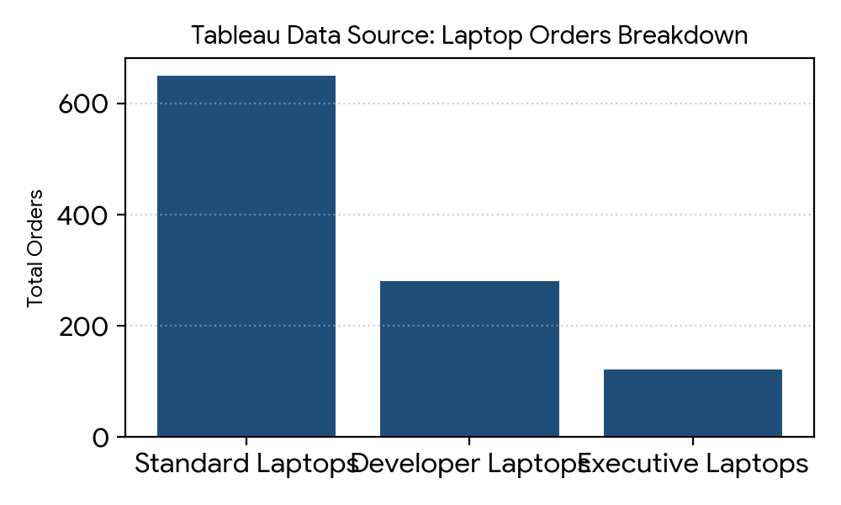
2 | Data Preprocessing | Utilized Tableau Prep Builder to resolve null cost centers, clean duplicate laptop request logs, and unify date formats.  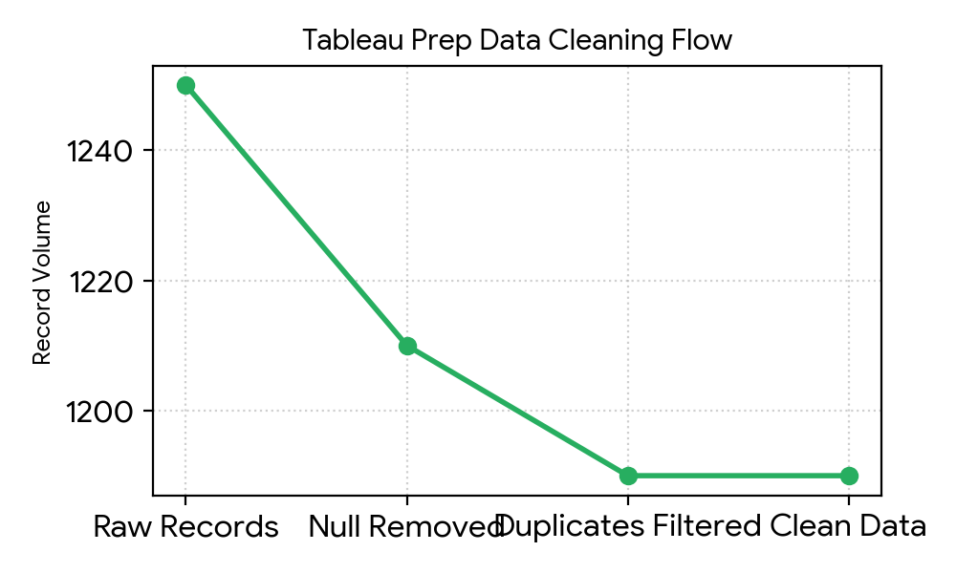
3 | Utilization of Filters | Implemented interactive Quick Filters for Department, Order Status, Date Range, and Laptop Model for dynamic drill-downs.  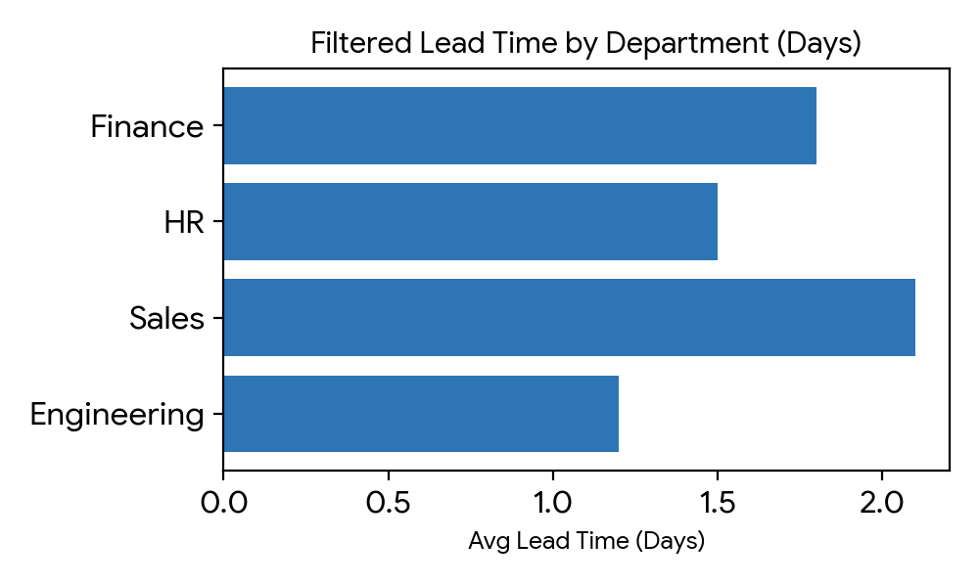
4 | Calculation Fields Used | Created Calculated Fields:  - [Automation Rate %] = SUM(IF [Auto Approved] THEN 1 ELSE 0 END) / COUNT([Order ID])  - [Fulfillment Lead Time] = DATEDIFF('day', [Order Date], [Delivery Date])  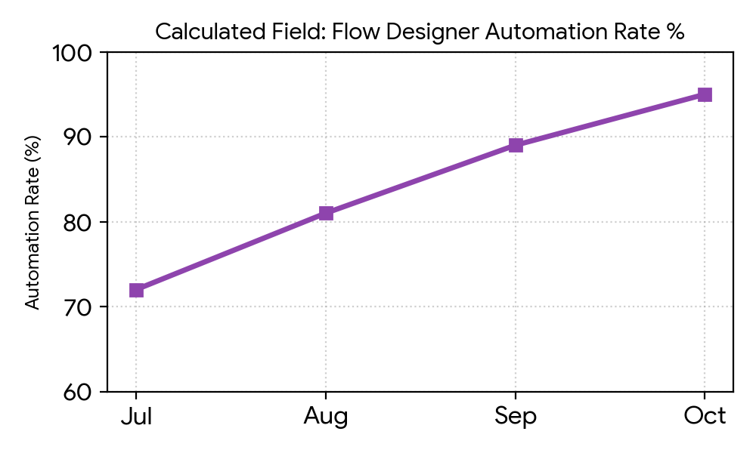
5 | Dashboard Design  (No. of Visualizations / Graphs: 6) | Built executive dashboard with 6 worksheets: Bar Chart, Pie Chart, Heatmap, KPI Scorecards, Tree Map, and Trend Area Chart.  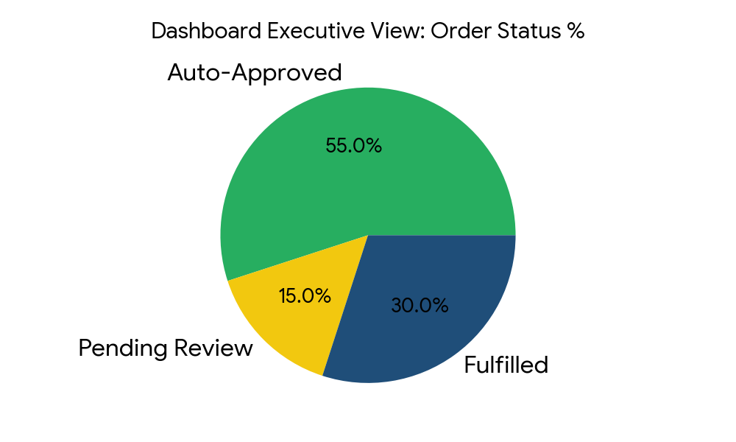
6 | Story Design  (No. of Visualizations / Graphs: 5) | Designed a narrative Tableau Story with 5 sequential story points highlighting Procurement Bottleneck, Flow Designer Speed, Cost Breakdown, and Delivery Timeline.  